Running REST API Test

1. Start the VM
The REST API is deployed inside a Linux virtual machine.
- Start the VM from your hypervisor.
- Wait until the OS finishes booting and you can connect via SSH or the console.

“Running VM”
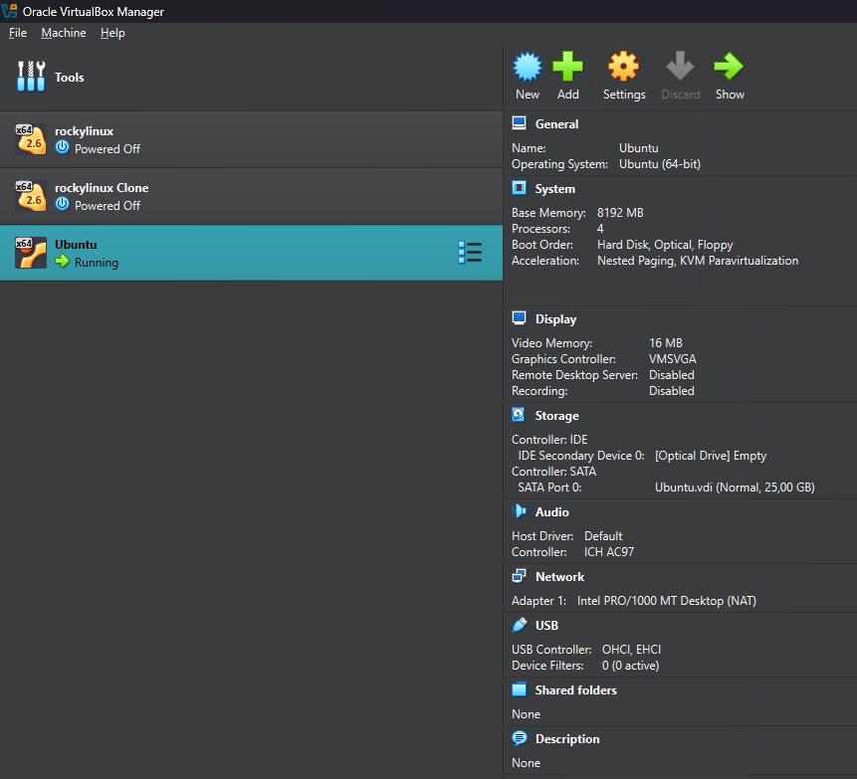
2. Configure Port Forwarding
To access the REST API from the host machine, configure port forwarding in the VM or hypervisor:
- Forward host port 8000 (or the port exposed by the container) to the same port on the VM.
- Save and apply the changes.
You should now be able to reach the API at:
- http://localhost:8000 (from the host)
“Port forwarded”
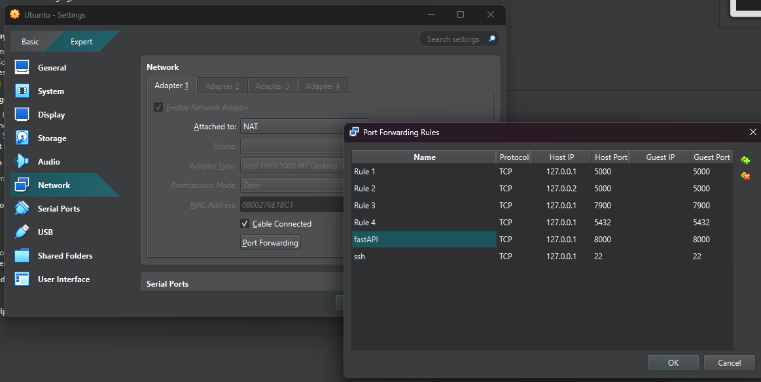

Verify Project Structure:
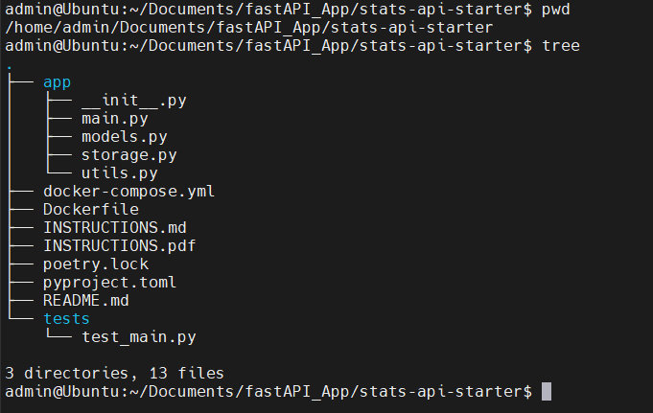

4. Build the Docker Image
Build the Docker image for the REST API. Wait until the build finishes successfully (no errors).
“Docker image building”
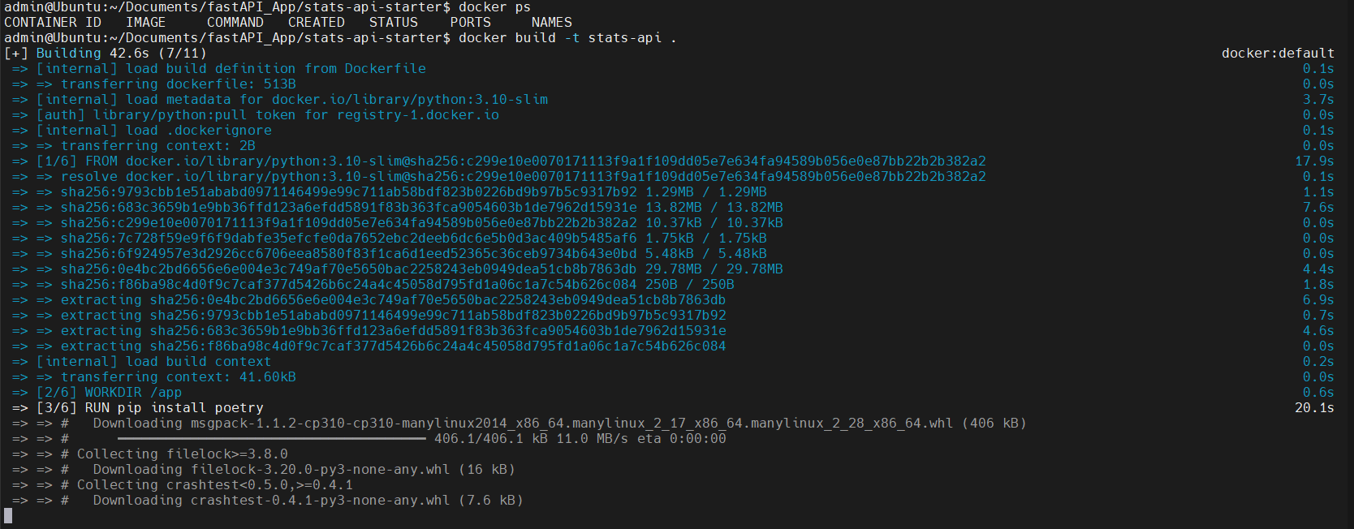
“Docker image build finished”
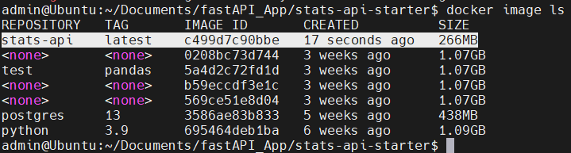

5. Run the Docker Container
Run the container, exposing the application port:
• --rm ensures the container is removed after it stops.
• -p 8000:8000 publishes the container’s port 8000 to the host’s port 8000.
“Docker image runned”
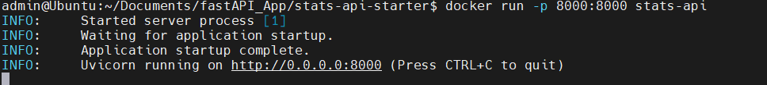

6. Check That the Application Is Up
Open a browser (or use curl) on the host machine:
You should see either:
- a simple welcome message, or
- the OpenAPI / Swagger UI at http://localhost:8000/docs.
This confirms the application is running and reachable from the host.
“Application is up”
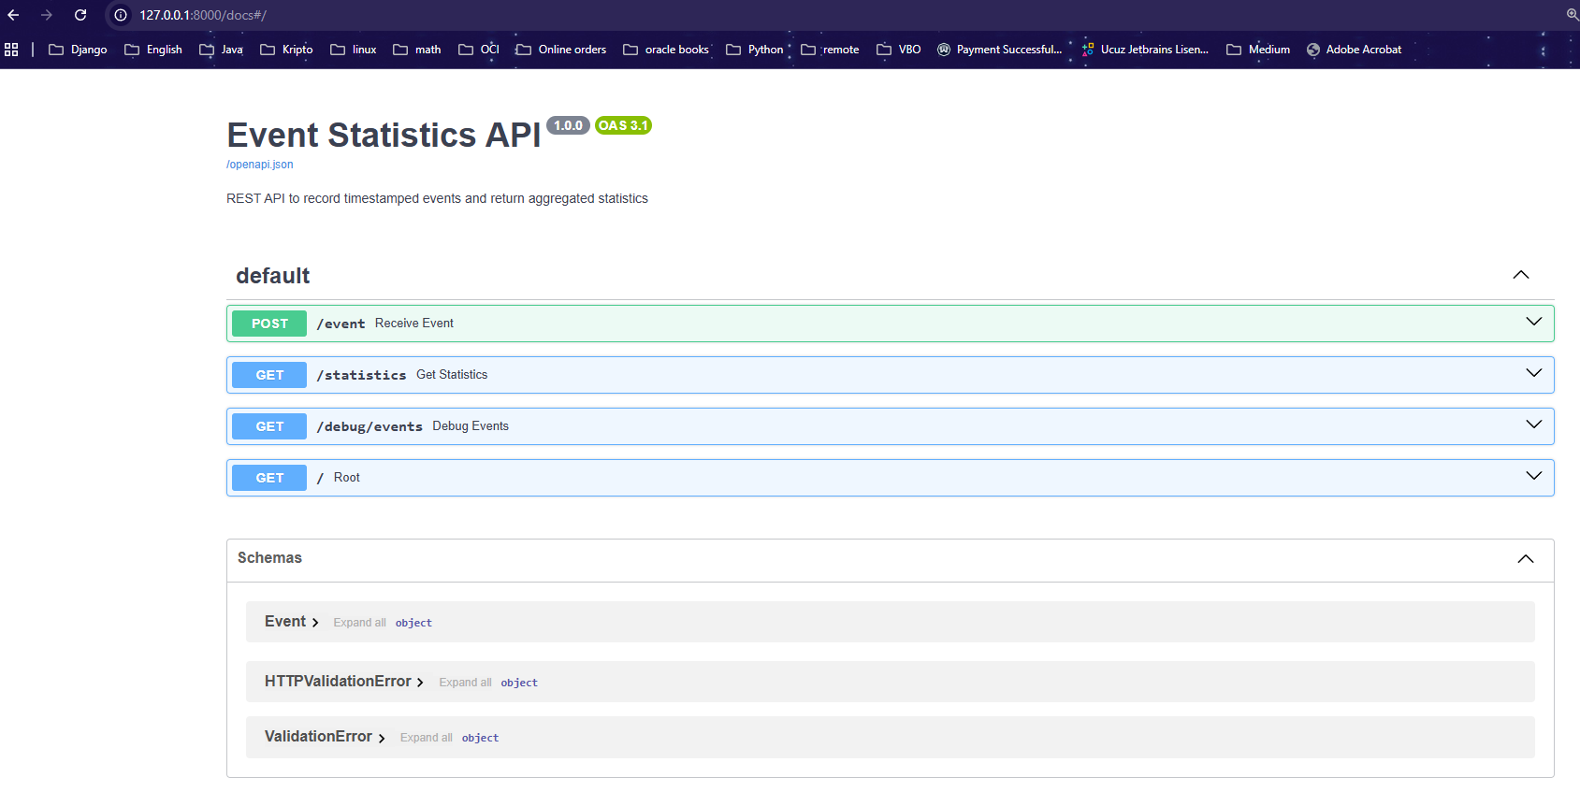

7. Insert a New Event (POST Request)
Send a POST request to create a new event (for example, using Postman or curl):
After sending the request, you should receive a 201 Created (or 200 OK) response and the event should be stored.
“new log inserted with POST request”
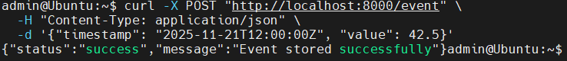

8. Get Statistics for the Last Hour
Now request statistics from the API:
The API returns aggregated metrics (for example: count, sum, average) for events in the last 60 minutes.
Initially, the response may contain null (or zero) values.
The reason is that the container uses UTC time, while the host and your test timestamps may be in a different time zone. As a result, your test event may fall outside the “last hour” window from the container’s perspective.

“getting statistics”
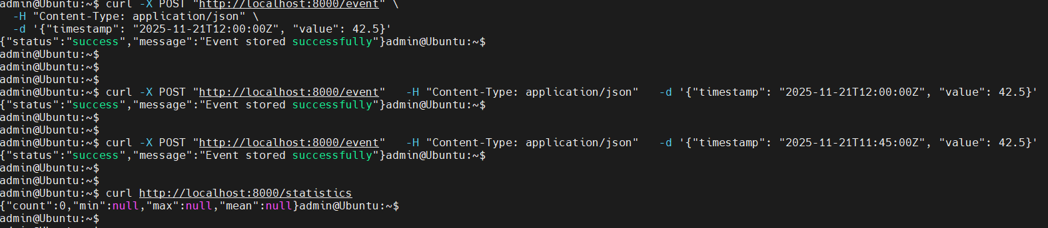
“We see nulls because of the container’s UTC date time difference”
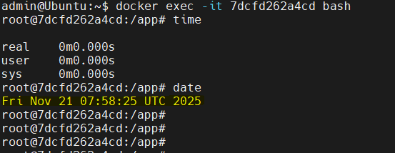
9. Adjust the POST Request Timestamp and Test Again
To fix the time window issue, send another POST request with a timestamp that matches (or is very close to) the container’s current UTC time. Use a timestamp within the last few minutes:
Now the event falls inside the last 60 minutes (relative to the container’s UTC clock), and the statistics response will contain non-null aggregated values.
(Screenshot: “Let’s change POST request and check again”)

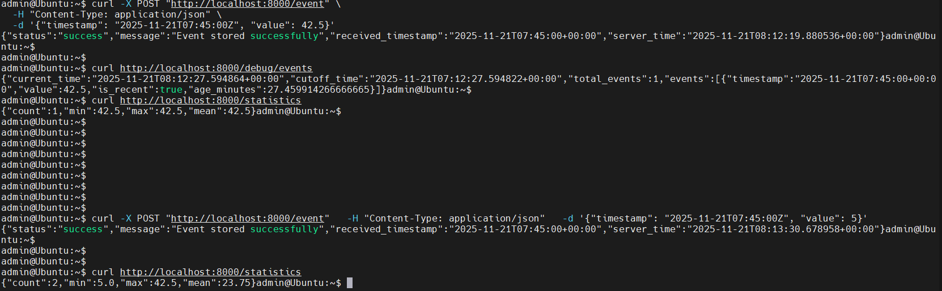

from web:
